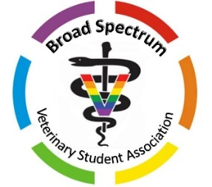

Broad Spectrum Veterinary Student Association
Grant Application
Name: ______________________________________________ Preferred Pronouns: ___________________ Class of: ___________
Veterinary School ____________________________________________________________ Date: ___________________________
E-mail Address of Applicant/Chapter: _____________________________________________________________________________
Please note that your organization must be either a recognized BSVSA chapter or another diversity club (e.g. VOICE, Diversity Council) with a BSVSA representative on the executive board in order for your application to be accepted.
In order to be considered, you must answer the following:
- Amount requested (up to $500): _________________________

- Agree to use any funds granted by Broad Spectrum VSA to support LGBTQ+ inclusion programs at your CVM
Agree [ ] Disagree [ ]
- Agree to submit summaries +/- photos of events hosted by your organization to Broad Spectrum VSA within one month of using the funds, as well as whether or not Broad Spectrum VSA leadership has permission to share the information.

Agree [ ] Disagree [ ]

- Have a chapter bank account (cannot be a personal account, do not list the name of the person on the account)
Bank _________________________________ Account Name____________________________________
- Please provide a paragraph on the second page of this application explaining how you intend to utilize the grant money.

- Please provide the address at which you would prefer to receive the check if your application is accepted:
___________________________________________________
___________________________________________________
___________________________________________________
___________________________________________________
Grant applications are accepted year-round but may not be available for the duration of the year, depending on the number of chapters that apply. Please submit your grant application as soon as possible to maximize your chance of funding.
Please submit materials and send questions/concerns to: broadspectrumoutreach@gmail.com
This grant generously sponsored by VCA Animal Hospitals.

Broad Spectrum Veterinary Student Association
Grant Application
In the space below, please provide a paragraph detailing how you intend to utilize the Broad Spectrum VSA Chapter Grant to support LGBTQ+ inclusion programs at your CVM (sample events are provided below):

Examples of Approved Events:
· Hosting speakers focused on LGBTQ+ issues
· Wellness events, including mental health events
· Socials for LGBTQ+ students and allies
· Letter-writing campaigns to enact change
· Diversity panels including LGBTQ+ vet professionals
· Events that help LGBTQ+ students identify safe preceptorships or job offerings

Please submit materials and send questions/concerns to: broadspectrumoutreach@gmail.com
This grant generously sponsored by VCA Animal Hospitals.

